Final Project: 1-Month Personal Fitness Plan Instructions

Guidelines:

- Develop a personal goal/goals you hope to achieve in the next month from this fitness plan.
- Next, select a template you want to use over the next month (you can always change it).

Templates:

- http://www.vertex42.com/ExcelTemplates/exercise-charts-and-logs.html
- http://www.bodybuilding.com/fun/printworklog.htm
- http://www.makeuseof.com/tag/10-excel-templates-track-health-fitness/

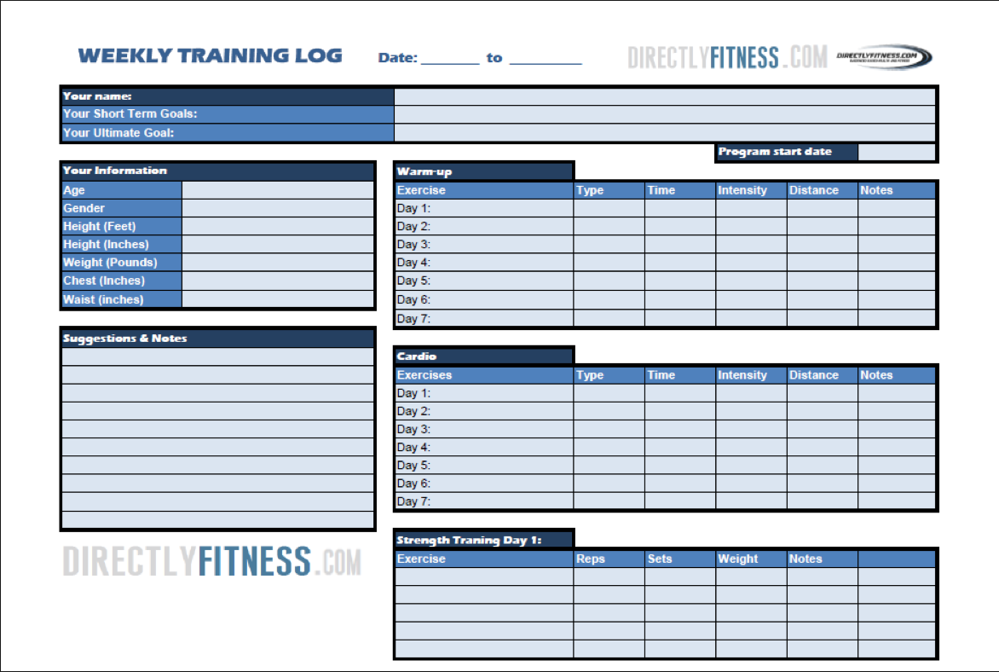

- Requirements:
  - Must have activity logged for a minimum of 5 days/week
  - Each day must contain at least 60 minutes of activity
  - Each activity logged must include details about the activity
    - When?
    - Where?
    - With Who?
    - How long?
    - How did you feel afterwards?
    - Did you enjoy the activity?
      - Example: 1 hour of pickup soccer
        - Tuesday at 6:30pm
        - Alicia Skatepark Soccer Field
        - With 2 friends and general public
        - Length: 1 hour
        - I felt tired after playing, but it was a lot of fun getting back out onto the soccer field! The game was free to play in, and afterwards we went to get a healthy meal in us. I felt accomplished after working out for the hour, and it was something I enjoy doing.
  - Basic nutrition must be logged during this month as well
    - List out the foods you had each meal (roughly how many calories)
      - Example:
        - Breakfast:
          - Banana (carbohydrate): 75 calories
          - Yogurt (protein/carbohydrate): 130 calories
          - Orange Juice (carbohydrate): 60 calories
        - Lunch:
          - Turkey Burger (protein): 200 calories
          - Hamburger Thins (carbohydrate): 100 calories
          - Almonds (fat): 130 calories
          - Grapes (carbohydrate): 80 calories
        - Snack:
          - Tuna (protein): 120 calories
        - Dinner:
          - Flame Broiler half/half bowl (protein/carb): 600 calories
  - Remember to list out the exercises/activities you did that day!
    - If the activity was in the gym, list out which exercises you did.
    - ANY ACTIVITY
      - List out the muscles impacted
      - List out the components of fitness most related to that workout

- Lastly,
  - Add as much detail into this fitness plan as possible! Not only will it significantly impact your grade, but it will be a great learning tool and useful practice for your future!
  - Take pride in your work!
  - Get out there and be healthy!

Rubric (by week = 30 points per week) /120

Category | 10 | 8 | 6 | 4 | 2
Content | Includes all of the activities completed, as well as the nutritional components for the day, the component of fitness most relevant, and the muscles most impacted. | Includes most of the activities completed, as well as the nutritional components for the day, the component of fitness most relevant, and the muscles most impacted. | Includes some of the activities completed, as well as the nutritional components for the day, the component of fitness most relevant, and the muscles most impacted. | Includes very few of the activities completed, as well as the nutritional components for the day, the component of fitness most relevant, and the muscles most impacted. | Content is minimal.
Professionalism | Makes excellent use of font, color, graphics, effects, etc., to enhance the presentation. The overall presentation is detailed, organized, and easy to follow. | Makes good use of font, color, graphics, effects, etc., to enhance the presentation. The overall presentation is detailed, organized, and easy to follow. | Makes sufficient use of font, color, graphics, effects, etc., to enhance the presentation. The overall presentation is somewhat detailed, organized, and manageable to follow. | Makes poor use of font, color, graphics, effects, etc., to enhance the presentation. The overall presentation is lacking detail, appears unorganized, and difficult to follow. | The overall presentation lacks effort in attempting to appear organized or easy to follow.
Requirements | All requirements (Activities, Time, Nutrition, Muscles Impacted, Component of Fitness, etc.) are met and exceeded. | All requirements (Activities, Time, Nutrition, Muscles Impacted, Component of Fitness, etc.) are met and well-detailed. | All requirements (Activities, Time, Nutrition, Muscles Impacted, Component of Fitness, etc.) are met, but lacking detail. | More than one requirement was not completely met. | Minimal attempts to meet requirements.

