Building a Fitness Plan Webercise
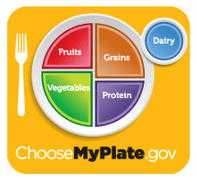

Lifetime Physical Education
Content Standards:
- HS Course 1 2.7: Develop and implement a one-month personal physical fitness plan.
- HS Course 1 3.5: Develop personal goals to improve one’s performance in physical activities.
  - Why is daily physical exercise important to overall health?
  - Students will understand all components of physical fitness.
  - Students will be able to develop a one-month personal physical fitness plan.
  - Student will be able to understand how to properly assemble and construct a personal fitness plan.
  - Students will understand the necessary components for a complete workout each day and week in the fitness plan.
Learning Objectives:
- Students will gain knowledge of the major muscles, and be able to successfully devise a workout plan for three consecutive days.
- Students will be able to list all components of physical fitness, and expand upon their importance.
- Students will be able to understand the importance of nutrition. Students will be able to differentiate certain foods from protein, carbohydrates, and fats.

Activity #1:
- Go to this website: http://www.choosemyplate.gov/
- Browse through the website for a few minutes and become familiar with its multiple pages.
- Then, click on the “Physical Activity” bar at the top, and then click “What Is It?”
- Answer the following questions:

- What is physical activity?

- Two examples of vigorous activity would include?

- What is the difference between moderate and vigorous physical activity?

- Click on the “Physical Activity” bar, and then select “Why is it important?”

- Name 5 benefits that physical activity can produce.

- If you are not staying physically active, you are more likely to develop what diseases?

- Under the “how much” portion of physical activity, answer the following questions.
- For adults, ages 18-64, how much physical activity is recommended per week?
_____ hours and ______ minutes at ____________ level.

- For kids ages 6-17, how much physical activity is recommended per day?

______ minutes per day and a minimum ______ times per week.
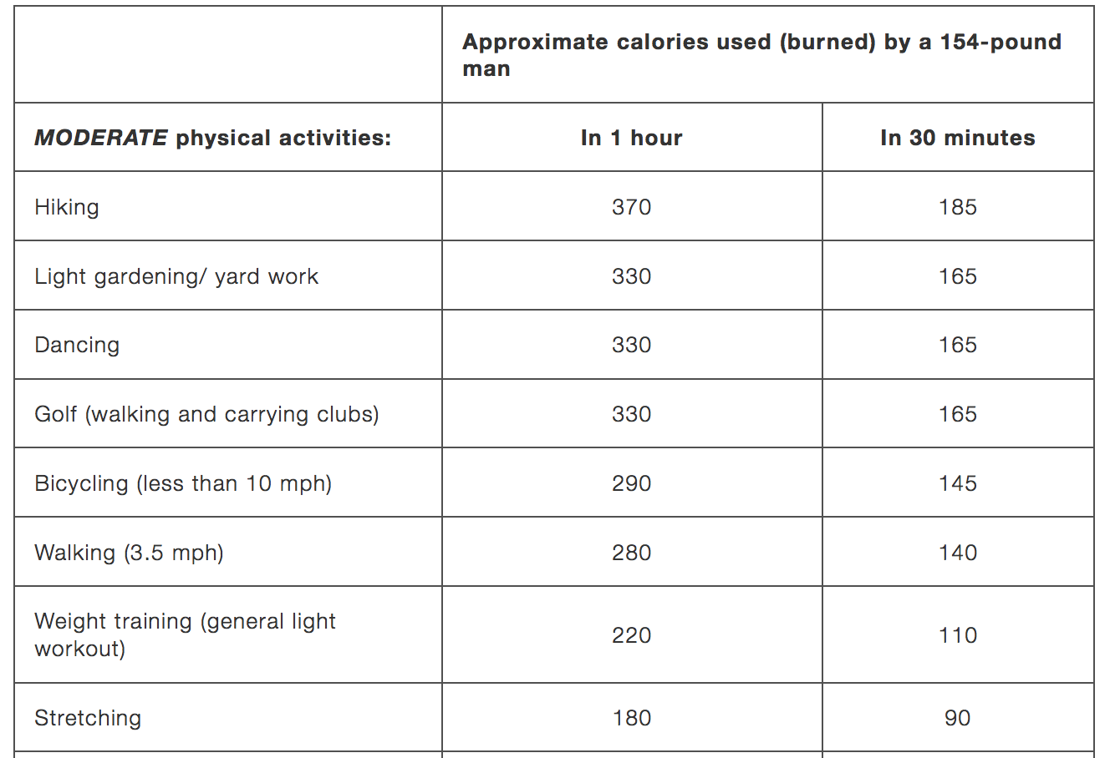
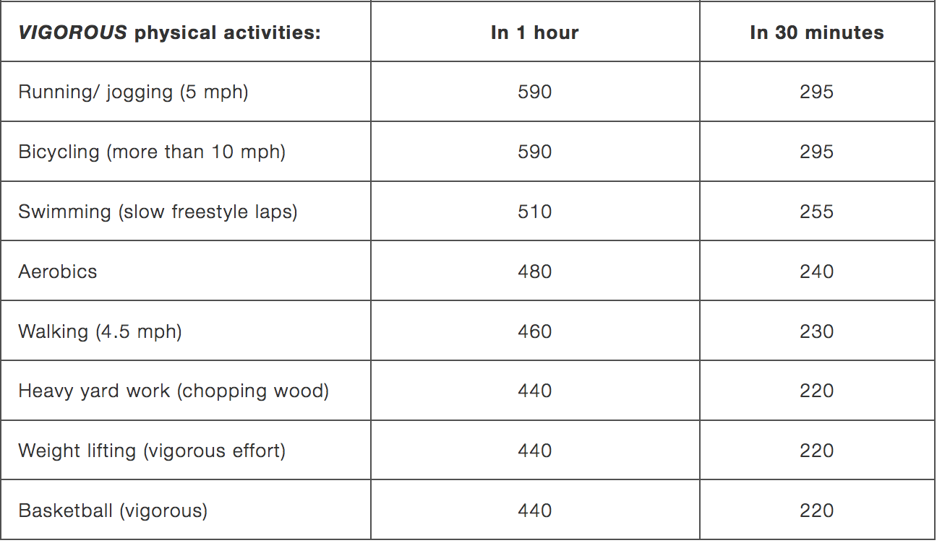

- Which activities produce the most amount of calorie burn per 1 hour for each level of activity? Which activities produce the least amount?

Most (Vigorous): ________________ ( ) calories
Most (Moderate): _______________ ( ) calories
Least (Vigorous): ________________( ) calories
Least (Moderate): _______________ ( ) calories

Activity #2:
- On the http://www.choosemyplate.gov/ website, browse the titles of “Healthy Eating Style” and “MyPlate.”

- Beginning with the “MyPlate” page, be ready to browse through all of the major food groups on the left hand side!

- Answer the following questions!

- How much fruit is recommended on a daily basis for boys and girls ages 14-18?

Boys: ______ cups

Girls: ______ cups

- List and name 6 fruits that you would like eating on a daily basis to maintain a healthy lifestyle, as well as the amount needed per day.

- How much vegetables are necessary on a daily basis for boys and girls ages 14-18?

Boys: ________ cups

Girls: ________ cups

- List and name 4 vegetables you enjoy eating or want to try!

- Name and list 5 grains that are listed on the table.

- How many ounces are recommended on a daily basis for boys and girls ages 14-18?

Boys: ______ ounces

Girls: ______ ounces

- Name 3 different types of dairy products.

Activity #3
Go to this website: http://www.cdc.gov/healthyweight/assessing/bmi/index.html

- Calculate your BMI score: _______
- Calculate your parents BMI scores: _______ ________

Activity #4

Go to this website: http://www.proprofs.com/quiz-school/story.php?title=chapter-2-components-fitness

- What score did you get on this quiz? ______/______
- What question did you feel was the most difficult on this quiz? What could I do to help you understand it better?

Activity #4

Go to this website: http://www.realbodywork.com/articles/game-muscles-1/
- Take the Level 1 and Level 2 Quizzes
  - There are muscles that we have not covered
- Write down the list of muscles that we have not learned here:

Activity #5
- The FINAL activity! Let’s get some critical thinking going here!

Answer the following questions to your best ability.

- Knowledge:
  - List the recommended amount of protein needed each day for the ages of 14-18 of boys and girls.

- Comprehension:
  - Discuss the multiple reasons and benefits that physical activity has on the body, and explain its importance of continuing physical activity in future years.

- Application:
  - Illustrate (draw) 2 different exercises that would be considered a cardiovascular exercise, and illustrate 2 additional exercises that would build muscle.

- Analysis:
  - Examine the differences in the amount of foods recommended each day for consumption. Why does each food group have different amounts? Explain your answer to the best of your ability.

- Synthesis:
  - Assemble a day’s worth of eating food. The food values must reach the recommended daily consumption value, but not go over. You get 3 meals and 2 snacks. Good luck!

      - Breakfast:

      - Snack #1:

      - Lunch:

      - Snack #2:

      - Dinner:

- Evaluation:
  - Justify why “bad foods” do not have to be completely eliminated from your everyday life. Provide reasons to support your answer. Then, compare the pros and cons to eating good food on a daily basis against eating bad foods on a daily basis.

